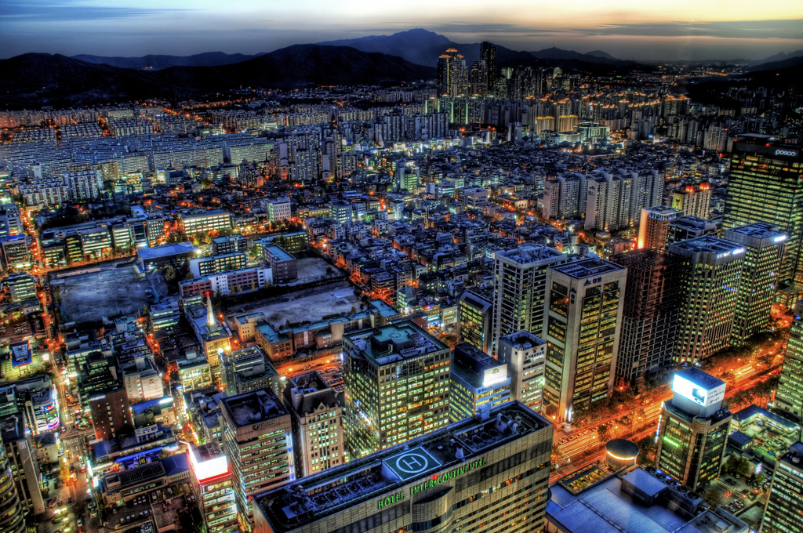

This photo is an excellent example of a combination between HDR and low light exposure. More than likely this landscape was taken right after sunset as you can still see a yellow colored haze off in the horizon to the right hand side. What really caught my eye was the use of HDR combined with low light. It really gives this photo a surrealistic look, almost as if everything is glowing, but at the same time there is an extreme sense of detail. It is easy to tell this was a long exposure from the excess of trailing lights at street level, instead of individual crisp vehicles you would see during the day. The only thing that does bother me about this photo is the fact that there is nothing stopping my eye and I have a tendency to let my eyes wander off of the photo onto the harsh background it is placed.